social media in business

Oliver Collins-Cope

Richmond Upon Thames College

BTEC National Foundation Diploma IT

Table of Contents

Introduction 2

Different Social Media Sites 2

Facebook 2

Audience profile of Facebook 2

Facebook and Business 4

Twitter 14

Audience profile of Twitter 15

Twitter and Business 16

Bibliography 27

# Introduction

The use and influence of business in social media is growing larger by the day, with more businesses investing in starting Social Media pages on different websites and applications, as the potential for growth and exposure comes at just the click of a button to post. With more people using social media applications and websites, with an estimated 3.78 billion users in 2021 (Statista Research Department, 2022), it is crucial for businesses to have an online presence, not only to advertise to customers, but in order to be au-fait with the current era and be able to provide a modern experience for the customer base, as well as provide adequate support where required using different features such as private messages, comment sections, and many more.

# Different Social Media Sites

## Facebook

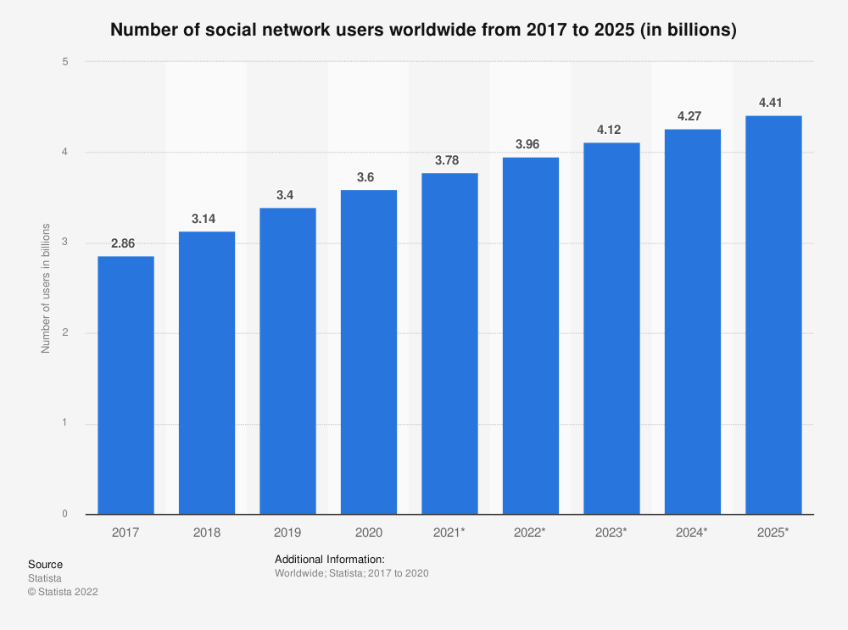Arguably the most famous and biggest social media giant out there, Facebook remains at the forefront of social media since it was founded in 2004. With around 2.9 billion active users in 2021 (DataReportal, 2021) (Iqbal, 2022) Facebook remains to be the largest social media site in use, beating YouTube in second place by around 600 million active users in 2021 (Statista Research Department, 2022) proving Facebooks status as a necessity for any business to grow and expand.

(Statista Research Department, 2022)

### Audience profile of Facebook

The largest demographic group of Facebook users is between around 25-35 years of age (Aslam, 2022). Around 56% of Facebooks user base is male, with the remaining 44% identifying as female, as Facebook does not allow users to select nonbinary gender types (Aslam, 2022).

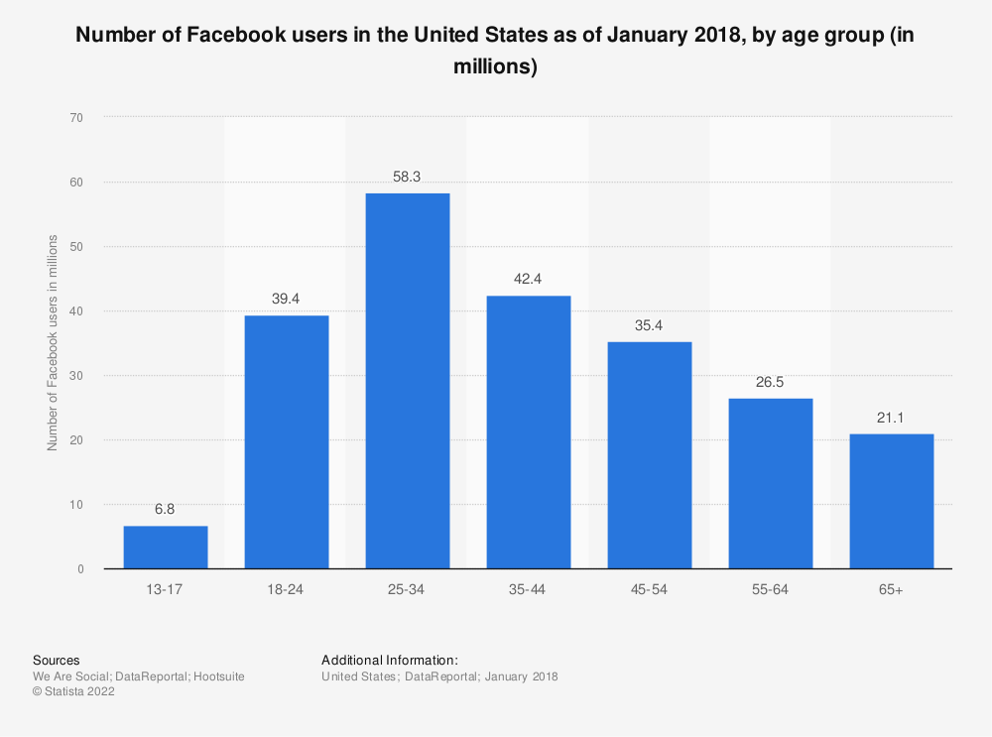

(Statista Research Department, 2022)

Within the largest age demographic of 25-35 years of age, 19% of all active male users are within this age group, and 12.5% of all females are within this age group, which are the highest percentage of any given gender in any age group, and makes up the majority of users as of October 2021 (Statista Research Department, 2022).

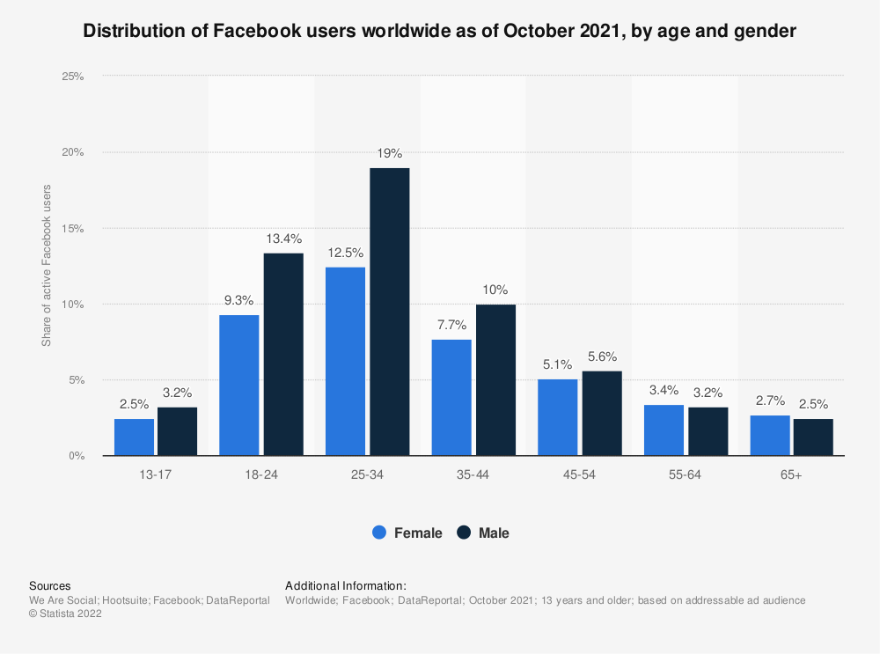  
The next largest demographic of Facebook would be the 18-24 range. Males in this age group make up roughly 13% of all Facebook users, while females make up around 9% of Facebook users (Statista Research Department, 2022).

### Facebook and Business

There are a number of features available to businesses on Facebook, which are not limited to just those available to a standard user. The primary features Facebook has to offer to businesses comes from the “Facebook Page” feature, which allows a user, or business in this scenario, to create a page for a specific thing, such as the business in question, and post on behalf of the business. In addition to adding a presence on the website, it also allows users to discover the business just through searching through a search engine and finding a social media for it on business, or searching through Facebook and discovering through that.

The features included with “Facebook Page” includes:

* Calls-to-Action
* Post Scheduling
* Profanity Filters
* Page Moderation
* Scheduling events
* Pages to watch/Up to date comparison
* When your page users are most active
* Statistics for post types
* Exporting page insights
* Target audience selection
* Creating Adverts
* Page Customisation (Aesthetic)

(Urrutia, 2015) (Howen, 2015)

(Quadros, 2021)

This is an example of a call to action, which incites customers to click on the button, which is beneficial to one’s business, and leads to another link when the button is clicked on.

An example of a call to action would be this –

The use app button which links the user to another website.

#### Post scheduling/Scheduling events

(Olafson, 2021)

As seen above, the post scheduling feature is self-explanatory, allowing users to post at specifically predetermined times in order to space out content or post when otherwise would not be possible.

Scheduling events works the same way, only through the events section of the page and creation options.

#### Profanity filters

(Shuffield, 2019)

As depicted in the picture, Facebook offers a profanity filter which means that depending on the level of strength chosen, certain profanities might be allowed, whereas when strong is chosen, all will be filtered out and messages containing profanities will be deleted or will have to be moderator approved.

(Urrutia, 2022)

As seen, page moderation allows users to blacklist specific words or phrases, such as slurs or swears, which would be damaging to the business if seen on the page.

In addition to this, it can also be used to keep content irrelevant to the business out of the page and therefore increase relevant activity towards the business.

#### Pages to watch/Up to date comparison

(Kolowich, 2021)

Through the pages to watch section, users and businesses can find how much interaction different pages have been having, including their own and other similar businesses, and therefore track different competitors and compare what was doing well and what was negatively influencing other competitors

#### When your page users are most active

(Facebook, 2022)

This feature allows businesses to check when users are most active on the page and therefore post at times that have highest activity, leading to a higher interaction rate.

#### Statistic for post types

Facebook allows users to check what types of posts receive different levels of engagement and their average interactivity for the different types of posts, and therefore post the content that works best with different users.

An example of what types of posts leading businesses use in the last few years is show below.

(Statista Research Department, 2022)

#### Exporting page insights

This gives the user to export any data from the designated date range about the page insights into a spreadsheet or whatever file format they prefer, in order to be able to analyse the data about the spreadsheet.

#### Targeting audience selection

The screenshot above shows how Facebook allows users to create specific audiences in order to target the customers and consumers whom they think will be more likely to purchase their product, such as maybe those who are 18-25, or male as opposed to male and female. This also includes setting up languages like only targeting English speakers with a specific audience profile.

#### Creating adverts

The Facebook business manager allows you to create adverts and select specific advert objectives.

Using this, businesses can create Facebook Ads that are managed by Facebook and promoted automatically or manually, depending on what the user decides.

Then the user creates an Ad using the campaign they created, or make a new one, and publish it.

#### Page customisation

This refers to things such as a custom page banner on the background, and custom profile picture, allowing the business to make the page about them and personalise it as needed for the page to be fit for the business.

Included in this is the about subsection of the page, with the following details available to be edited.

An example of this in Facebook KFC –

## Twitter

Twitter is another social media that is important to consider as it is another one of the most popular forms of social media, with user numbers reaching 430 million in 2021. Twitters key characteristics lie in the fact that users/businesses are limited with the number of characters they can use to post, specifically 240. This means that any posts made on Twitter are concise and to the point, as users do not have the freedom to make long and complicated posts without making a long thread of posts. This kind of simple and fast content is on the rise in modern media, with applications like TikTok basing their entire app on short videos.

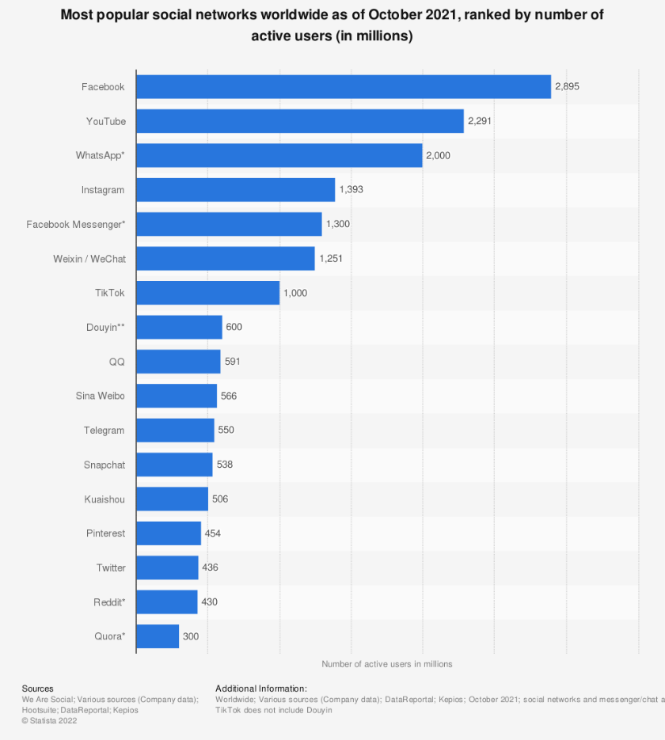

(Statista Research Department, 2022)

### Audience profile of Twitter

The largest age demographic within Twitter is between 25-34 years old with 38.5% of the total users being within this age bracket as of 2021.

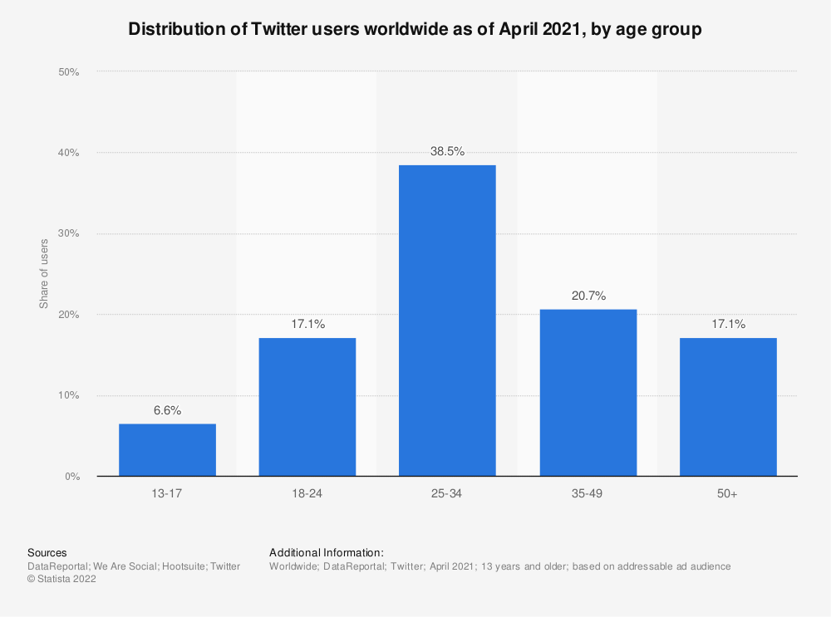

(Statista Research Department, 2022)

Within this, 70.4% of all Twitter users are male, meaning that the male population of Twitter has a significantly larger population compared to women, who only 29.6% of the population. When it comes to the US however, this number is slightly different, with men only having 61.6% of the total user base of Twitter, and women having 38.4% of the remaining users.

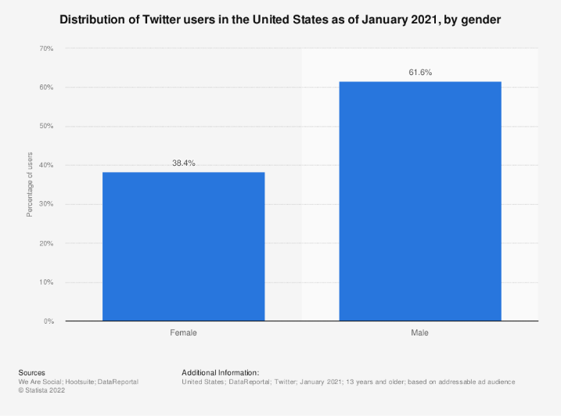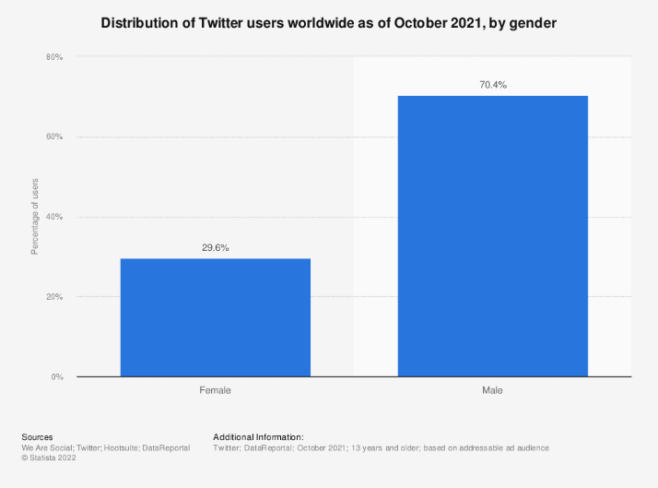

(Statista Research Department, 2022)

It is also important to note that Twitter provides options for non-conforming gender designations.

This means that those who use Twitter for business will focus primarily on advertising to late 20’s to early 30’s with their products, along with more focus on the higher population of male users on twitter, which may lead to a divide and gap between the amount of focus on one gender compared to the other.

### Twitter and Business

Twitters unique characteristic of only being able to post 240 characters means that businesses must be concise with their posts and straight to the point. This could potentially be a big advantage to businesses and users when it comes to direct advertising, as it may encourage users more directly to buy their product. Another benefit of the character limit is that it encourages companies/users to post videos and images rather than just text posts, which have a higher interactivity rate amongst users.

Other features of business in Twitter include:

* Twitter for Professionals
* Twitter Ads
* Analytics
* Hashtags
* Live “What’s happening”
* Direct messages
* Customer interactions
* Pinned tweet
* Customisations
* Retweeting
* Media
* Likes
* Call to action
* Scheduled posts
* Word filters

#### Twitter for Professionals

Twitter for Professionals is a feature that allows businesses and users to create professional accounts dedicated to running a business and providing the necessary content to promote and uphold that business. This allows for a clearly defined presence on the platform, which is separate from the original user.

An example of a professional Twitter account could be KFC again, but on Twitter as opposed to Facebook this time.

#### Twitter Ads

Twitter Ads refers specifically to a section of Twitter where a user or business can create an Ad.

Twitter Ads allows you to create different kind of advertisements for specific countries and time zones/currencies.

From here, users are given the option to choose their adverts objective, from awareness, to consideration, and finally conversion.

As shown below, users are then able to decide more specific details about their Ad.

#### Analytics

Analytics refers to a specific part of the site where the business for a summary analysis of their page.

This allows businesses to view their “tweet impressions” which means how many times a user saw your tweets. Profile visits refers to how many times users clicked on and viewed the businesses profile, and “followers” allows businesses to check how many followers they have either lost or gained overall.

It also shows the best tweet a business put out, and best images/video an account put out.

#### Hashtags

Hashtags are a key part of Twitter, as they allow businesses to create topics and context for their tweets. Any hashtags that are clicked on by users will show any other posts made using the same hashtag, whether made by the original tweeter or not, and therefore allows for users to create threads under the same hashtag. In addition to this, popularly used hashtags often become “trending topics” and are promoted on general users Twitter.

#### Live “What’s happening”

This refers to the “What’s happening” part of the page, which coincides with “hashtags”.

#### Direct messages

Direct messages allow businesses to directly and privately message individual users. This can be very helpful for when users have issues or complaints which need to be dealt with quickly.

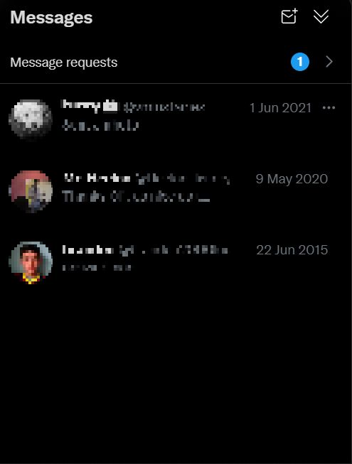

#### Customer interactions

This simply means that Twitter accounts and businesses interact with customers on their page, rather than simply direct messaging them, in order to either help resolve issues or just respond to their tweet.

#### Pinned tweet

Pinned tweets are tweets that are open as soon as the user clicks on the Twitter account, no matter how long ago it was tweeted.

#### Customisations

This allows businesses and users to customise their Twitter account, from their header to the profile picture, or the biography and link.

#### Retweeting

Retweeting allows Twitter accounts to share tweets their want to through their page, with the message that it was retweeted, essentially allowing them to “retweet” that tweet.

#### Media

Media is one of the sections on a Twitter accounts page where users can view an accounts different post that involve media, such as videos or images.

#### Likes

Likes is similar to media, except it involves the tweets that the account “likes” and allows users to view this.

#### Call to action

#### Scheduled posts

As seen for Facebook, this allows accounts to schedule when they make posts.

#### Word filters

Similar to page moderation for Facebook, this allows accounts to block prechosen words, such as swears or slurs.

# Bibliography

Aslam, S., 2022. *Omnicore.* [Online]   
Available at: https://www.omnicoreagency.com/facebook-statistics/#:~:text=56%25%20of%20the%20total%20Facebook,to%20only%20male%20or%20female).&text=(Source%3A%20Statista)-,The%20largest%20demographic%20group%20of%20Facebook%20users%20is%20between%20the,of%20the%20popul  
[Accessed 1 February 2022].

DataReportal, 2021. *DataReportal.* [Online]   
Available at: https://datareportal.com/essential-facebook-stats  
[Accessed 1 February 2022].

DataReportal, 2022. *DataReportal.* [Online]   
Available at: https://datareportal.com/social-media-users  
[Accessed 1 February 2022].

Howen, A., 2015. *Website magazine.* [Online]   
Available at: https://www.websitemagazine.com/blog/10-facebook-business-page-features-you-should-be-using  
[Accessed 2 February 2022].

Iqbal, M., 2022. *BusinessOfApps.* [Online]   
Available at: https://www.businessofapps.com/data/facebook-statistics/  
[Accessed 1 February 2022].

Kolowich, L., 2021. *Hubspot.* [Online]   
Available at: https://blog.hubspot.com/blog/tabid/6307/bid/28441/the-15-best-facebook-pages-you-ve-ever-seen.aspx  
[Accessed 8 February 2022].

Olafson, K., 2021. *Hootsuite.* [Online]   
Available at: https://blog.hootsuite.com/how-to-schedule-facebook-posts/  
[Accessed 8 February 2022].

Quadros, M., 2021. *Adespresso.* [Online]   
Available at: https://adespresso.com/blog/call-to-action-examples/  
[Accessed 8 February 2022].

Shuffield, J., 2019. *DavesComputerTips.* [Online]   
Available at: https://davescomputertips.com/how-to-turn-on-facebook-profanity-filter/  
[Accessed 8 February 2022].

Statista Research Department, 2022. *Statista.* [Online]   
Available at: https://www.statista.com/statistics/278414/number-of-worldwide-social-network-users/#:~:text=How%20many%20people%20use%20social,almost%204.41%20billion%20in%202025.  
[Accessed 1 February 2022].

Statista Research Department, 2022. *Statista.* [Online]   
Available at: https://www.statista.com/statistics/272014/global-social-networks-ranked-by-number-of-users/  
[Accessed 1 February 2022].

Statista Research Department, 2022. *Statista.* [Online]   
Available at: https://www.statista.com/statistics/398136/us-facebook-user-age-groups/  
[Accessed 1 February 2022].

Urrutia, K., 2015. *Single Grain.* [Online]   
Available at: https://www.singlegrain.com/facebook/12-important-facebook-features-every-marketer-needs-to-take-advantage-of/  
[Accessed 2 February 2022].

Urrutia, K., 2022. *VoyMedia.* [Online]   
Available at: https://voymedia.com/how-to-block-words-and-profanity-from-your-facebook-page/  
[Accessed 8 February 2022].